Memories
Written by Harry Donald Wetzel
I am starting this in March of 2000. One of my first memories is of the Westclox alarm clock that sat on the window in the kitchen. It faced to the east. The second thing I remember was standing in the garden. My mom got the camera and took a picture of me holding a doll in the middle of the garden.
I remember one of our earlier Christmases. It was very cold outside. My brother Jim was not born yet. We had to take our bath in a washtub. Robert was first, I was second, and of course, Dale was last. The water was cold when I got in so it must have really been cold when Dale got in. I think the year was 1931. Finally, Santa Claus pounded on the door. It was so very cold. He had a gunnysack on his shoulder and a very ragged Santa Claus suit. He dumped the contents on the floor and out came three little packages. When opened, there were three little cars in them (almost the size we later got in Cracker Jack boxes as prizes). Times were very hard and all we knew were hard times. We were content.
My Family History
I must backup a little. I was born September 8, 1927. I think it was in the Strip Mine, a mining town located between Zap and Beulah North Dakota. My father came to North Dakota from South Dakota with his parents, John and Ida Wetzel and 14 other children. My father told me they spent their first winter in a little shack about a mile east of Glen Ullin, right close to where Highway 94 now runs. Later the next spring they homesteaded on a farm west of Beulah, along the Spring Creek. My grandfather had a bad habit; he liked to gamble. After the threshing season, the card sharks from Bismarck would come to Beulah. They would feed him drinks and after about two days and two nights, they had most of the money he had made. He later lost his farm because of this. We went on vacation one time in South Dakota near where he had first lived. My father asked quite a few people if they remembered him. The answer was, “You mean that gambler?” It must have been a lifetime affliction. My mother’s family, the Henry C Werner family, lived in, I think New Ulm Minnesota, where he and his brother operated a meat market.
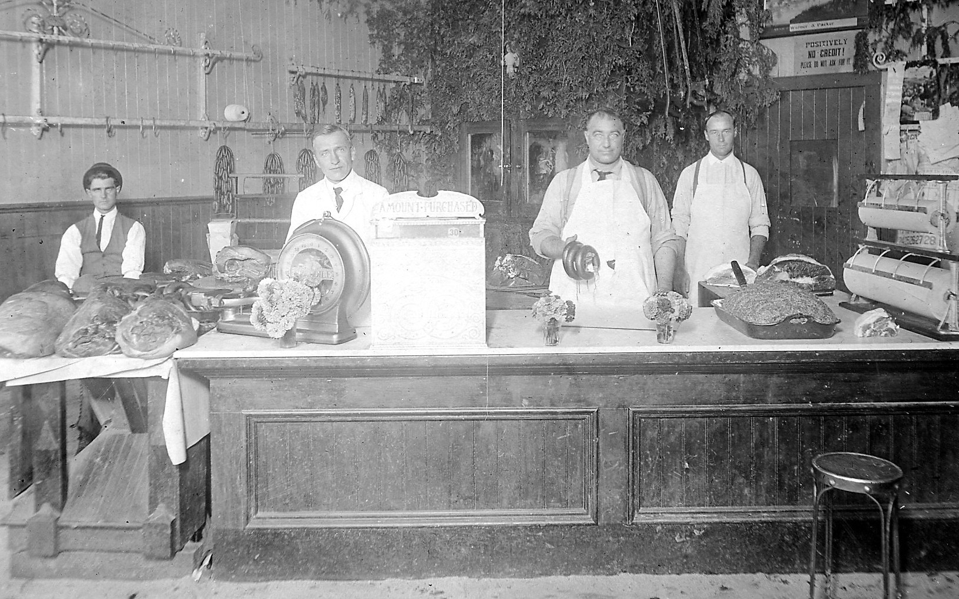

Werner Meat Market, 1890s
Grandfather originally moved onto the ranch in 1898. He brought his family up from Elmore, Minnesota in 1903. My mother was born in 1898. He homesteaded the land, my grandmother homesteaded a quarter also, and I think my Aunt Gwendolyn homesteaded a quarter.
When my grandfather homesteaded near Hazen, the railroad had not yet arrived in this area. He built a two-story house on the Ranch, as we called it. When the railroad arrived, the house and barn would have been separated by the railroad tracks. The story my mom told me was that my grandfather and grandmother were out on vacation in the Yellowstone Park. My mom and her sisters stayed on the railroad tracks with rifles and would not let the construction separate the buildings. After my Grandfather returned home a deal was struck, whereby the railroad would move the house to a new location. My Aunt Jo tells me she was riding in the house and her mom wanted water to cook with. Someone handed her a pail through the window.

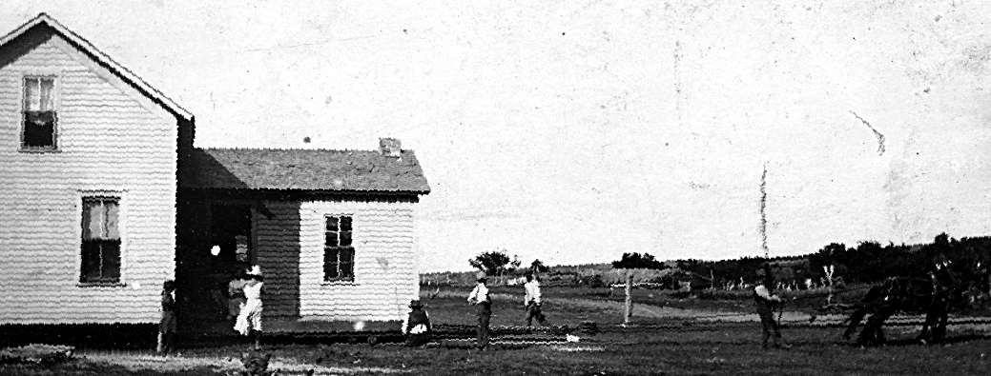

Moving the Henry Werner Ranch House
In about 1917, my uncle, Ross Werner died at the age of about 17 from a ruptured appendix. He was the only boy in the family.
My grandmother died from blood poisoning in 1926 so I never knew her. Later on, my Aunt Gwendolyn died from the same. She died early in life and had married a Staley. They had one son that I know of, Carleton. He was a fine fellow who came back to visit us when he was in the Naval Air Force during the Second World War. He was a pilot of a seaplane and advised my brother Jim that was the best place to be. Some years later, my brother Jim enlisted in that branch and spent 30 years there, coming out a captain. He flew sea planes most of the time.
I once asked my Aunt Jo why they died from such a simple thing as blood poisoning? She told me there were no antibiotics in those days. My Grandmother died in St Mary’s Hospital in Rochester, Minnesota. My Grandfather took her there by train. At that time, my Aunt Jo was teaching school at Taylor, ND. She caught the train to Rochester; she had only one week of the school year left. Her mom died before she arrived in Rochester.
My Grandfather took in a homeless waif from Minnesota by the name of Charles Croy who stayed with him until the Second World War. Charlie was taken from his parents; they were part Mexican I think. The story I was told was his father purchased a tractor to farm his land. He could not pay for it so they took the tractor and the land. The children were put up for adoption. I think Charlie was about 7 years old. My Aunt Jo said he arrived on the train in Hazen. He had a cardboard nametag on his neck and my grandparents met the train and took him home. In later years, it was just Grandpa Werner and Charlie on the ranch. They had no electricity or running water. A well was just outside the Ranch house. In the summertime, they would lower their milk, cream and butter down the well to keep it cool.
Childhood Memories
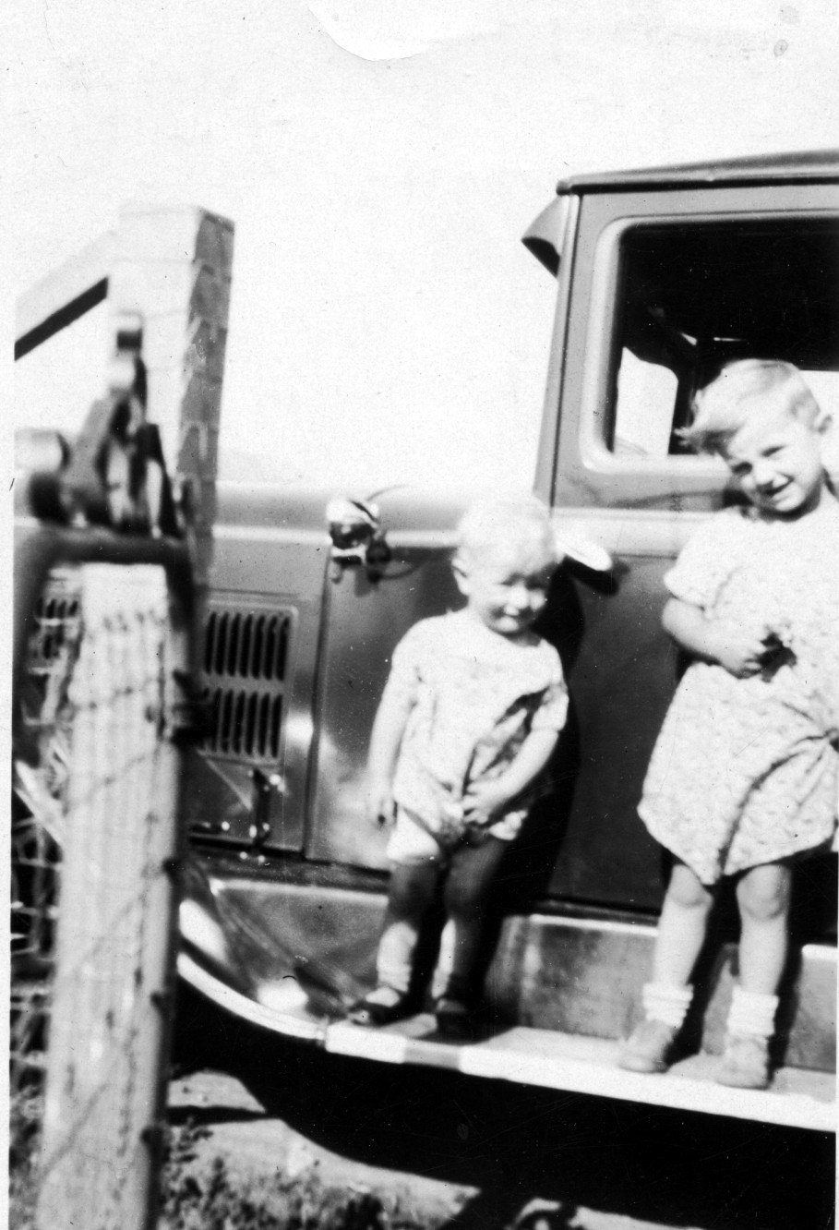
I can recall when I was quite small driving down to the Spring Creek to wash the car. We swam in the shallow water. The car was washed with buckets of water. I do not know if we had running water at home at that time. Anyhow, no one had a garden hose. I think there was a picture taken then.
Donald and Dale, about 1929
My parents had a little Christmas tree. I do not remember if it was a bare branched tree with decorations to resemble leaves or not. Of course, they did not have electricity. There were a few candles on the tree, which they lit on Christmas Eve. Charlie had a pail of water ready in case it got out of hand. They blew out the candles very soon. I did get a little sailor suit for Christmas. It was from Jo or Marge.

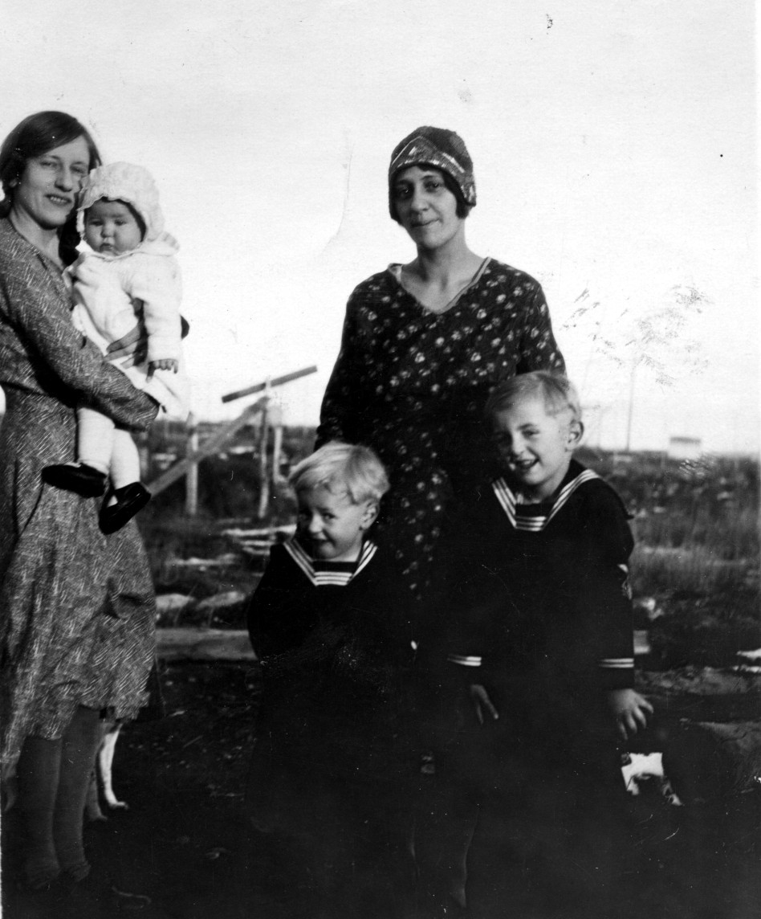

Joanne Werner holding Robert Wetzel
Francis Wetzel with Donald and Dale

The 1930s
Aunt Marge’s husband, Quentin Gallagher, was in the Navy. Years later, in the Second World War, he was in every major battle in the Pacific. He told of one ship he was on where there was so much blood on the deck, they had to spread sand on the deck. He also told of a sailor with a big eagle tattooed on his chest. After a shell exploded close to him the skin with the eagle was on the wall back of where he was standing.
When I was about four or five years old, my parents went somewhere, and Dale was the babysitter. I do not think Jim was born yet. We were sleeping in our parent’s bed and I fell out and broke my arm. I remember crying. When my parents came home, they put me into my own bed. The next day they took me to the doctor in Beulah. For some reason I had to go on to Bismarck. I suspect because perhaps they had no X-Ray machine in Beulah. They must have left me in the hospital to be taken care of.
I remember they took me into a room to play with toys. My arm was in a cast. Then they put me back into a room with about four cribs. My crib did not have a side on one side, so they put that against the wall so I could not get out. I put my feet against the wall after they were gone and got out of the crib. I went looking for the toy room. I was apprehended before I could find it. I was put back where I belonged but this time my crib had all the sides on it. I can remember my mother looking into the room. I was so happy. I think they took me home then.
In the 1930s drought set in. It seemed like the only thing that grew were Russian thistles and grasshoppers. I remember my mother pointing to the sky and you could not see the sun through the cloud of hoppers migrating to another field. You could see the sun glistening on their wings. They would land in a field and devour all of the greenery. They would even eat fence posts. The farmers would put up the thistles for hay. It gave the cows diarrhea and it was not safe to stand within 8 to 10 feet of their backsides!
In 1933, Franklin Roosevelt became president. He had some crazy idea to help the farmers. He purchased all or some of their cattle. The cattle were herded west of the Strip Mine Village to a caved-in area from an old underground coalmine shaft. Our family friend, Athias Renner, had a repeater rifle and was standing in the box of a truck. He shot the animals and they were thrown into the old shaft. We were raising silver foxes to make money on their furs. My father had permission to take a couple the cows’ hindquarters to feed the foxes. We were not supposed to eat any of the meat but we did cut off some and ate it. The only meat people had to eat in those days was chicken. We did not have a refrigerator so we could not keep it long. We usually fed the foxes Purina Fox Chow. I do not know how dad could get credit to purchase that.
I had my own little flock of chickens, white leghorns. We got a penny a piece for the eggs. Wheat sold for 60 cents a bushel and I would take a quarter and a gunnysack to school to buy 25 pounds of wheat and take it home on the bus.

My chickens were very good egg-layers. Our chicken house had only one window high on the west side of the building. We had a coal stove out there and in the wintertime, it was my job to keep it going. I attended it in the morning and again in the evening. I kept it warm enough so that the water very seldom froze.

It was also my job to haul the coal in for the house. We had a coal shed built on the north side of the house. I had to carry the coal around to the south side of the house where our entry was. Later on, Dad built a tile chicken coop and the whole south side was second-hand windows that were scrounged up from some place. When the sun shone on cold wintry days, the chickens seemed so happy, scratching the straw and clucking. We would allow them to set, which is to lay a clutch of eggs and set on them until they hatched. It saved buying baby chicks. I have no idea what they cost in those days. We did sneak some pheasant eggs under the hens. When they hatched, they would just disappear.
We had a coal heater in the living room and a coal cooking stove in the kitchen. We kept them going 24 hours a day in the wintertime. In very cold weather, ice would form on our water pail in the kitchen (even though it sat right next to the range). I remember our heater in the living room getting red hot after Dad would come home from work, chilled to the bone. It seemed like it always got red hot on the backside and not on the front where we were sitting. We hauled the coal into the house in five-gallon pails and as I recall, in cold weather we had at least four pails in the house.
There was a time when the coal mine did not work or Dad was not needed. He would go off to Canada, I think, to work in some mine. I remember getting letters. He lived in a bunkhouse up there. It had to be in the early 30s. I remember my mom peeling very little potatoes and saving the eyes to plant in the spring. I can recall asking my mom, how come all we ever eat is bread and potatoes. It was all we had, she told me. My Aunt Jo told me, we boys used to pick up small pieces of coal from the coal bucket and eat them.
We had a large fenced-in area with seven smaller fences inside where we kept the silver foxes we raised. The smaller fences had wire across the whole bottom so the foxes could not dig out. There were a pair of adult foxes in each of the smaller fences. In the spring, each pair would have from two to five young ones. At this time of year, the only person allowed to go inside was Dale because he always fed them. It was his job to grind up the horsemeat and he added, I think cod liver oil, or something like that. This was in the late 1930s. Farmers would sell their old horses that were anywhere from 17 years old on up. My father would buy them for a couple dollars. We would butcher them and sell the hide for three to four dollars. We usually would get about a dollar more than we paid for the horse.
When Dale was about 13 years old, he was allowed to drive the car and pull the four-wheel trailer my father had built. There were always kids who wanted to go along just for the ride. We never did take lunch and I do not recall taking any drinking water. In those days no one bought lunch meat, I do not know if it was even available. As times were so hard, missing a noon meal was nothing. We were always happy to have extra help because it was hard to roll the horse over to skin the other side.
I was the one to shoot the horse. I used my father’s .12-gauge Browning automatic shotgun to kill the horses. Outside of slaughterhouse personnel, I bet there is no one that has shot as many horses as me. We always had enough of the neighbor’s kids wanting to go along; our car was packed. We would skin the horse but it took the whole car full of kids to turn it over so we could remove the hide. We would then cut off the front and hindquarters, load them in the trailer, and be on our way home.
I was quite small and every time I shot that .12-gauge, it almost tipped me over. One time we purchased a horse north of Dodge, North Dakota. My father wanted to put it in our uncle’s pasture and fatten it up. He decided I would ride it that 15 miles and Dale would drive the car home. The horse was very skinny and its backbone was like an upside-down V. I do not remember how many miles I was able to take that punishment; I was riding bare back. I think I made about six miles before I could go no further. We took the halter rope, held unto it out of the car window, and almost dragged it along. When we finally got it to the pasture, it laid down and for a few days, we did not see it get up. As for me, I did not care to sit down for a few days.
Our house had a coal cooking stove in the kitchen and a heating stove in the living room. Both rooms were quite small. In the kitchen, we had a water pipe about two feet from the kitchen range. No sink, just a water pail on a little stand. In extremely cold weather, there would be ice on the water pail. I imagine in our bedrooms the temperature would get down into the twenties. We would fill both stoves with coal at night and turn the dampers off so they would not burn fast, but just smolder. In the morning, there would be hot coals and we would just add more coal. In the back of the kitchen range, we would fill a water reservoir with water. Usually it was not too hot; but it would get warm. We used this to wash our hands and face in a washbasin and we did dishes with this water. The wastewater was disposed into a five-gallon bucket with other refuse, which was emptied outside when full. Of course, we had no bathroom but an outside toilet, which we would have to dig a new hole for every couple of years.
My mother had to bake bread in the coal stove. In the wintertime, it was okay. However, in the summertime, when it was 90 degrees, the house would get so hot we would all go outside. She would usually bake between six and eight loaves. We could not afford yeast, so we kept starter yeast in a jar in the basement. After use, we would add more water and a little sugar. In a couple days, we had a new batch of yeast. If we ran short, we could always borrow some from the neighbors.
In the summer, we would pick chokecherries and wild plums and make jelly. This would also heat up the house. We could not afford Sure Jell or it was not on the market yet. We had to boil the juice until most of the moisture was out. It was a hit and miss deal. Sometimes it would get so stiff you could hardly spread it on your bread.
As times were so hard, we had a very large garden. At times, we had two potato fields. There were gray potato beetles and Colorado potato bugs. We had to walk down the rows and pick them from the plants. The gray beetles would move quickly but the potato bugs were slow. We would pick them up by hand and drop them in a pail filled with oil or kerosene. Later on, we had a chemical called Paris Green that we mixed with water and put in pails. We then dipped old paintbrushes into the mixture and shook it off on the plants. This chemical was outlawed later.
The worst thing was the hoeing. Robert and I would like to go fishing but we could not go until the potatoes were hoed. We argued we would do 2/3 of them and Dale could do his own. He usually slept until noon. We usually ended up doing both fields so we could go. We would pop out of bed at daybreak, grab our cherry stick poles with the heavy mason line and large hooks and be off, without eating. We would catch grasshoppers for bait and usually get home about 2:00 or 3:00 p.m.. with a stringer of suckers, and bullheads. If lucky, we would also have a shiner, or gold-eye, as they are now called. We took no lunch and drank from the Spring Creek. We were told if the water ran over ten feet of sand it was purified. It is a wonder we did not get sick.
We did not have a refrigerator or anything but a coal stove for cooking. We had another coal stove in our small living room for heat. My mother baked bread once a week, and washed clothes once a week. She had to heat the water on our kitchen range. There was a water reservoir on the right-hand side, which held water. It would be heated somewhat. We used this for washing dishes. I remember in the summertime it was never very hot and if we washed a greasy skillet, it would not get very clean. The skillets were all black cast-iron. We did have running water as the water line that went down to the shop was right under our house. In the wintertime when it got very cold, the water pail would have ice on it. It sat about three feet from our kitchen range where we kept the coal burning all night. Our house was not very tight. I used to tell a lie about how loose it was. I would say I threw my hat into the air and the wind blew it outside through a crack in the window frame. It was not quite that bad.
I remember going out to Grandfather Werner’s Ranch one Sunday in the wintertime. We had a very heavy car, an Essex, with no power at all. The road out of the ranch was very steep and the road had drifted in. We slipped all over the place and could not get out. The ranch house was about ¼ mile away, but they must have been watching. It did not take too long for Charlie Croy to appear on the scene with a team of horses to pull us up the hill. Of course, they did not have electricity. In the summertime, they kept their butter, cream, and milk in a pail that they lowered down into the well. That was a common practice then.
There was a power line not too far from their home and my grandfather could not understand why the Power Company would not connect them. This was in the 1930s. The reason they could not be connected was the power line was because it was 41,600 volts. It would have cost many thousands of dollars for the transformers to reduce to 120-240 volts. Later on, I worked for the power company that owned this line and understood the reason.
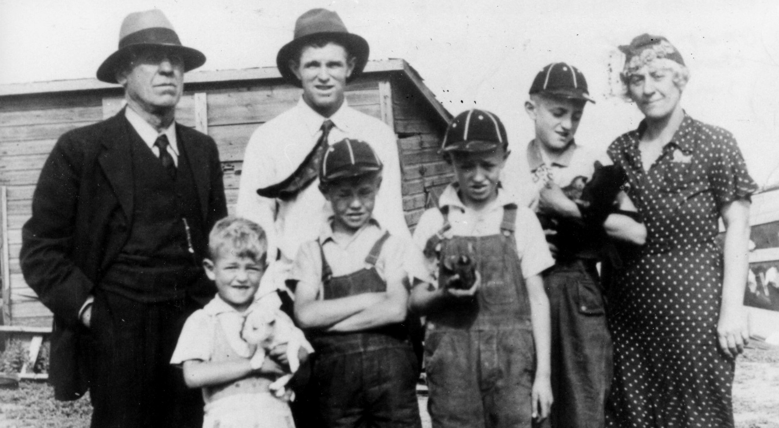
Grandpa Charles Werner & Harry Wetzel Family, about 1935
My Grandfather had a Model-T Ford At least once a summer we would get a post card from him telling us he would be up on Sunday. We were always happy for this occasion because we usually had fried chicken. I remember riding in the Model-T up the hill to come out of the ranch. It did not have enough power, or else the timing was off, to make the hill. I would get a big rock and lay it behind the back wheel. He would race the motor and then step on the low pedal and scoot ahead a little. The Model-T did not have a gearshift; you stepped on a pedal for low. It had bands similar to brake pads, only round. When you wanted to go in high you pulled back on a lever that engaged the high bands. This car was in good shape and later on in life, my brother Jim got it. When people came across these rocks on the side of the hill, they called them a rock bridge. We always moved them out of the road.
In about 1934, my Grandfather quit ranching. Prices were terrible and there was no feed. I remember when they drove the cattle to Hazen to the stockyard for shipment. I was with my Grandfather and he had a pair of binoculars to see how the cattle drive was coming. He did not volunteer to let me look through them, but I surely itched to. Years later I did look through them. They were not very good glasses.
Grandfather’s house in Hazen was very small with no running water. Dad later dug a well in the basement and put in a little hand pump. I think he cooked on a little kerosene stove. He did have a furnace in the basement. I do not ever recall going down there.
School Days
My first year of school, we rode in a covered wagon, which was pulled by a team of horses. In the wintertime, the girls would put bricks in the coal ovens at home and get them hot. They carried them in cloth bags and put their feet on them to keep their feet warm on the ride to school.
At school, they just kept them close to the stove to warm them for the ride home. The ride was about 2½ miles.

I recall our old schoolhouse when in the first four grades. It was not very large. I think all of the high school students shared one room. Coal stoves heated the rooms. At that time, everyone had coal. No one had kerosene or any other luxury cooking means. There was a large tin enclosure around the stoves themselves so students would not bump against the hot stove. Most of the time, the teacher would attend to the fires. There was a stove just like this when I taught school south of Beulah that one-year in 1946-47. We had no electricity either.

When in school in Zap, if you whispered, the teacher would put a large band of tape on your mouth for the rest of day. It would be removed for lunch and replaced after you ate. We carried lunch boxes. In the wintertime when the stoves were hot, she would open the enclosure and warm up the tape so it would stick better. There were no bathrooms. Just outside toilets. If you had to go, you would raise your hand with one finger for number one or two fingers for number two. Do not know why the teacher had to know what kind of urge you had.

I cannot recall if there was drinking water available. We went to school in this schoolhouse until I was in the fifth grade. We always carried a lunch pail. Usually it was chokecherry or plum jam on home made bread. We never did have meat sandwiches until about the time I was a freshman. Then I would shoot pheasants and fry pheasant breasts for sandwiches most every day. We drank water, no milk, in school. Dad had a thermos bottle for work. Not stainless steel, but the kind where you could buy the glass replacement inner thermos container. His would get broken from time to time.
The 1930s were very dry. Wind blowing and dust clouds. In about the 3rd grade I had a friend almost as bashful as me, Teddy Beck. We would stand outside the schoolhouse trying to keep the dust out of our eyes. We always had to go outside after we ate our lunch from our lunch pails. I do not remember what our lunch consisted of. Perhaps chokecherry jell sandwiches, as we always seemed to have that. Of course, it was on home baked bread because no one ever had store bread except for a very special occasion. I remember having it twice; both times at birthday parties and it was made with sandwich spread like you buy today. No one had money to buy it for every day. We also had Jell-O and I think at one time we had angel food cake at Joe Pulver’s. His mom used to work at a bakery. It took at least one dozen egg whites. There were not cake mixes in those days.
Anyhow, my little friend Teddy and I got along fine. Christmas vacation came and when we returned to school the teacher informed us that Teddy had died with pneumonia over the vacation. I do not remember a close friend in school for the rest of the year. My cousin, Fern Buechler was a cute girl with long blonde hair. She was my age and a great help to me. She was smarter than me, and would sit with me and help me with my schoolwork. Her family moved to Oregon when she was about in the 4th grade, but we kept in touch all of our lives. She passed away in about 1998. She was always my favorite cousin.
I remember when we were all down at Grandfather Wetzel’s one time. We were playing outside when our parents rushed us to the backside of the house. Fern’s little sister, Evelyn had fallen asleep under the wheels of a car parked there. When the party decided to leave, he backed over Evelyn and killed her. I do not know if she was two years old yet. Her grave was unmarked until about 1990 when Fern had a marker put on her grave. She is buried south of Beulah.
Then along came Darold Anderson and we became fast friends. After about two years, his family had him stay with an aunt in Stanton, Inga Hoffman. He stayed there until his parents moved down north of Jamestown. Years later he confided in me that he always considered me his best friend and I had always felt the same. We still keep in touch and he was here in Sept of 2000. We went to a funeral in Zap for Albert Beck who was 93 years old and our old neighbor. They had lunch after the services, and it was amazing how many people he remembered after 60 years. Of course, most were old strip miners. After Darold left, my brothers and Sparky Wittmaier were my closest fiends. This continued until I was in high school. At that time, Chip Unruh and I became good friends, a friendship that continues to this day. In fact, we were pheasant hunting yesterday.
I had a tough time in school the first few years. I always sat way in the back row and I needed glasses and could never see what the teacher was writing on the blackboard. Sometimes at noon hour, I would try and see it but we were not allowed in the schoolroom at noon hour or recess. The teachers sent home a note to my parents. They did take me to Mandan; there was not an eye doctor any closer. He told my parents that I was pretending and did not need glasses. He said I just wanted to wear glasses for some unknown reason. I did not get glasses until I was a freshman in high school.
I used to walk outside at night and see the neighbor’s lights on through their windows. It was just a blur of light. I was amazed when I got my glasses to see the blur was a square window. The same thing was true at the movies. I used to set with my friends in the middle of the theater or in the back rows and could only see blurry objects. What a difference after I had glasses.
The days at the Strip Mine were happy days. We always stuck together and the town kids as we called them never would tangle with us, except for one time in the fifth grade during a very quiet study hall. It was so quiet you could hear a pin drop. I inadvertently passed a large amount of gas. The sound could be heard throughout the whole room. Everyone looked over in my direction. I was sitting in the second seat from the rear. To shift suspicion, I turned around and stared at the person behind me. It was Christ Richau, the biggest boy in the class, almost twice my size. Everyone thought it was he who had let that one go. My parents had purchased sheep skin coats for us, and they were very heavy. I was wearing one and after school, Christ caught me outside the school grounds and was going to beat me up. Every time he got close, I would swing as hard as I could. I missed him every time, but I knew I was a goner if he got his hands on me. After about three swings, a high school boy, Leon Bellon, came out, grabbed Christ by the collar, and kicked him in the butt. He told Christ, you big bully, if I catch you picking on some one so much smaller again, I will give you a good beating. Christ never did. I think he failed that grade, as I do not recall too much about him later in school. My schoolmate Eldora Hintz stopped to see him out in California some years ago and told me he was a millionaire. He had gotten into demolition and salvage and made a bundle. He was even going over seas for work. He was big, but not dumb, evidently.
My parents looked for ways for us to make money. We had a paper route where we sold magazines like Colliers and many name brands. We would go house to house. No one ever said come back next week. The ones we could not sell we just cut off the name and returned it and we were not charged for it. In the spring, we would go house to house and sell garden seeds.
Dad told us if we would make money, he would purchase us a bike on the installment plan. We had just bought a very old bike for about $2.00 but the seat was too high for my short legs. Dad went to Beulah and ordered a Schwinn bike. It had a horn on and a light. Seems to me after the first set of batteries we did not buy more batteries.
Junior Beck came to me one day and said he knew where we can get some babbit. The mine would pay eight cents a pound for it. So, we gathered some tools and he took me down to the tipple. His father was foreman, so he knew what was going on. Down at the tipple was a great big drum-like affair. I think it was for oil or something, but it had a shaft with a lot of bearings. We worked about two days taking these bearings out and removing the babbit. Junior gave it to his dad to sell. I do not remember getting any money. Then we heard that this was a machine they had shipped in and intended to use. The mechanics had to rebabbit all of those bearings. Nothing was ever said to us, but they must have seen those two little boys taking that apart.
Another time about mid-winter, Junior had another wild idea. He suggested we run away from home and hide in an old beaver hole by the Spring Creek. He was going to steal a ham from home so we would have something to eat. He must have been in trouble at home. We didn’t ever do this, thank goodness.
About this time, the government started the WPA program. It would provide work for men and in turn, they could get welfare. It was all public works projects. The women would go to Stanton on the train and sew clothes. Our neighbors, the Beyls, had clothes made down there. They were square cut and very loose fitting; almost one size fits all. Mrs. Beyl did go to Stanton to sew. They also handed out some food that was surplus. My folks would not go on this program. They chose to do it without help.
When you would see the men working on a dirt project, they were often standing and leaning on their shovels. They did not have dirt-moving machinery except for the tumbling bug. A scraping contraption pulled by a team of horses. When it was full, the operator would rise up on the handles and it would tip the dirt out in front.
In the 1930s, things times were very hard. The coal mine did not work in the summertime. The coal they mined was used for heating home. There was no demand for it. My parents would charge their groceries in the summertime. When winter came and they started getting paychecks, they would pay the new bill and pay a little on the unpaid summer bill. By spring, they would be caught up. There were no food stamps, or unemployment, or other help. I think the county had a relief service for the really misfortunate. My parents were too proud to go on relief. When they purchased groceries, all they ever bought were the staples: salt, flour sugar etc. I think they only went to town every two weeks for shopping, on payday.
Then came a difficult time. The mine could not pay the men. The storeowner heard about it and cut off our charge accounts. The mine then opened its own store. The deal was, we could charge groceries and they would subtract that from their earnings and pay them the difference. After a year or so, the mine told them they could not pay them. They would just cancel our grocery bill. I do recall when winter came, my father went to the superintendent and told him he had to have some money to buy us shoes and clothes so we could go to school. He did give him some. I think it was about $25, which was quite a bit. Shoes perhaps sold for a couple dollars a pair,
Some people really charged a lot at the store. At the very end of this time, about 15 months, the mine started to pay the men again. They said they could not afford to pay the back wages. They forgave the grocery bill for that period. I do not remember how long the store was open there. I knew one family, Art Bauers, who charged an awful lot of things, like bread and donuts. I do not think they had a fresh meat counter. In Zap, they had coolers of some sort because my mom bought round steak twice a month. This was after 1937 though.
At this stage in life, I became an entrepreneur. We would pick chokecherries and sell them for 25 cents for a milk bucket full (about three gallons) or one dollar for a washtub full. We could carry the milk buckets, but the washtubs were too heavy. Robert and I had an order for a washtub full. We picked it and carried it up to the highway, but we still had about one-half mile to go. I sent Robert home to get mother and she came with the car to haul them home.
We roamed the Spring Creek fishing, swimming and hunting. One day Junior Beck and I were fishing. We were about two miles from home and close to the Fred Sinerius farmstead. We met Bennie Sinerius, a very nice boy about one year younger than us. He took us up to the well to get a cold drink of water. It was about 2:00 in the afternoon. We had left about 6:00 a.m. without eating. Bennie’s mom came out and asked us if we had eaten yet. We told her no. She came back out with a slice of homemade bread topped with homemade butter and a couple radishes. That tasted so very good and to this day, I enjoy bread and radishes. It was tough times and they did not have much. They were on the verge of losing their farm.
Some time later, Robert was playing cowboy and Indians with Sparky Wittmaier. He ran out into the road in front of an oncoming car driven by Eddie Bushbacker. It was a car with not much road clearance. It ran right over him, and he rolled out of the back like a Russian thistle. His scalp was almost all torn off; it hung over his face so he could not see. He had a broken arm and I think a broken leg. My dad was not around. He was out looking for work in the harvest fields, working a couple days here and a couple days at the next farm.
I do not recall how we got Robert to the hospital. Dad came home and the next night we went down to the hospital in Beulah. It was right across from the Catholic Church on the west side of the street. We were sitting in the waiting room when they carried a man on a stretcher within three feet of us. His face was partially bandaged, but you could see BB marks on the outside of the bandages. The man was Joe Runions, who owned a local car repair shop and was a Deputy Sheriff. An official from the Bank of North Dakota had come out from Bismarck to investigate some missing storm windows, and other items missing from the farm that Fred Sinerius had lost. The official wanted to have a sheriff help reclaim the property. Sinerius’ had lost the farm because they could not make the payments. They were forced to move to a smaller place about a mile to the west. The two went over to confront Fred about the windows and an argument ensued.
Fred grabbed a gun from inside the door and shot Joe at close range with a .410-gauge shotgun. The man from Bismarck ran but Fred grabbed a .22 rifle and shot him in the back of his head as he was running. He was dead. Joe was not, but he played dead until Fred left. I do not know if it was dark. Joe got to a nearby farm and asked to be driven to the doctor. The woman could not drive but Joe instructed her, and he had to do the shifting. Joe died that night. He was a good friend of Elmer Gentz. The men in Beulah were going to lynch Fred. The authorities heard about that and moved him to Bismarck that night. Fred died in prison many years later. His widow lived in Zap until her death and their son, Bennie moved to Montana. The day of the shooting Bennie came home from school and saw the dead man laying in the yard and he ran off and hid for quite some time.

When I was about 12 years old, in about 1939, my father decided to install an indoor bathroom. We had a trapdoor in the middle of the kitchen, and Dale and I had to dig the basement larger so we could get back under the room where the bathroom was to be installed. It was hard clay and very dry. We would fill a five-gallon pail with dirt and walk up the stairs and out through the kitchen. We were very sloppy and left quite a mess, spilling the dirt on the kitchen floor. My poor mother had to clean up after us when we were through. We would carry the dirt outside and dump it. Dad found something like the grain elevators farmers use to move their grain into the granaries. After we had made enough room for the little elevator, all we had to do was shovel it unto the elevator. It would carry the dirt outside. I cannot remember if it had a gas or electric motor on it.
Next, we had to dig a trench about three feet deep and ten feet long. At this point, we had to dig a septic tank hole. We did not have a septic tank though. We dug a hole about 12 feet deep. After we were down too far to shovel the dirt out, we would fill five-gallon buckets and pull them up with a

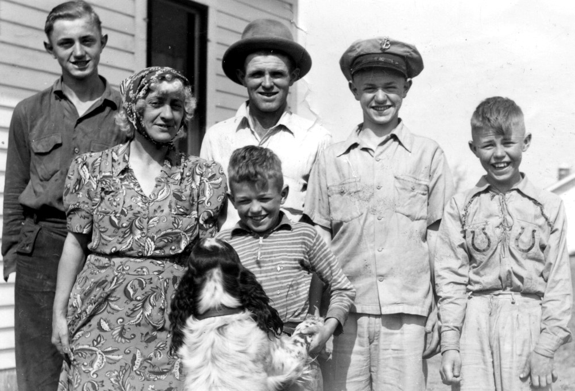
Harry Wetzel Family, 1940s
My grandfather told me when he first arrived in the Hazen area; the hills were literally covered with thousands and thousands of prairie chickens. At that time, there were no red foxes or raccoons here. The first raccoon I heard of around here was in about 1944. The foxes appeared after they built the Garrison Dam. They were on the north side of the river but did not cross.
When I was young, I went down to the Ranch with Aunt Jo and maybe Aunt Marge, Grandpa Werner and Charlie Croy. At this time, I saw my first ring-necked pheasant. My grandfather participated in the planting of these birds and guarded them zealously. There was a straw pile just south of the house and in the evenings, they would come to find food. We did not see them any place else for quite a few years. In the 1940s, they were all over but when I first saw them, it was about 1931.
Lenore’s Grandfather Herman lived in Glen Ullin. He told me when he was a boy, he met Sitting Bull and received a small medallion from him. The railroad was not through at this time. Every year great herds of antelope would migrate north in the spring and back in the fall. The spring after the railroad went through, he said a great herd of antelope arrived at the railroad tracks and were afraid to cross. They milled around for several days and went back south. We did not have antelope here until they replanted them in the 1950s. Even now occasionally when we have too much snow they winterkill because they cannot scratch enough snow away to get at the grass. They do not go close to farmsteads like the deer do.
My father was getting about 30 cents an hour. We could sell a jackrabbit for 25 cents each. When the fur buyers would pass, they would have a cattle truck with high racks filled with frozen jackrabbits and coyotes. The fur was used to make felt and the meat, for fox and mink feed. There were no foxes here at that time. I started to trap skunk. They sold for $2.50 to $3.50 each. I could make as much with a big skunk as my dad did working for ten hours. We would also dig them out, grab them by the tail, and drop them in a gunnysack. I once carried two in a sack for over two miles. They did not spray while in the sack. I put them in an empty fox house and fence as it was too warm and the hunting season was not yet open. I fed them pheasant scraps when we cleaned pheasants.

One morning when I went out to feed them, one got excited and sprayed my shoes. I went to school that way. Everyone complained about the smell. No one knew who the culprit was. Dale’s room was adjacent to my schoolroom. Somehow, they thought it was Dale who smelled badly. He was sent home; of course, he had to walk. After he left, they remarked about how long the odor lingered, and, it lingered until I left at 4:00 pm. I kept the skunks for about three weeks. The day after hunting season opened, they disappeared. Later on in the week, Joe Pulver told me that Bud got two skunks that day. What a coincidence. I knew where he got them.

That was not the only time I had that misfortune. Chip and I had some traps north of the Strip Mine, a little north of where Highway 200 now runs. When we arrived at one of our sets, the trap was pulled way down into the hole. I pulled on the wire to get the trap out. It pulled hard but finally it came. We had caught the skunk by the hind leg, and it came out tail first. As soon as it could see me, it raised its tail and sprayed me in the face. It burned like fire. I grabbed some fresh snow and started wiping my face. After I regained my composure, we did it again with a little more caution and then shot it with our .22 rifle. Where the perfume hit my face, I had little blisters like water blisters from a burn.

The other time I was not so lucky, Joe Pullver and I had one in a trap, but no gun. It was near a small spring that had little pools of water. I had the bright idea of drowning it. It seems they have to have their front feet on the ground to be able to swing their tail over their back to spray. The plan was, Joe Pulver would hold the skunk by the wire attached to the trap and lower it enough so I could take a forked stick and hold its head under water and drown it. Well, somehow it dug its feet into the mud enough to arch its back and throw back its tail. Again, I was the target, and it connected. Well, I took a club and knocked it out and then submerged his head and drowned it.

One time, Chip and I were returning from checking our traps north of now Highway 200. As we crossed the frozen Spring Creek, I broke through the ice. I was wet up to my chest. It was 20 below zero. We had to walk about ¾ of a mile to get to the railroad tracks down by the Strip Mine tipple. There was a warming house there with a coal stove for the workers. When I got there, my pants were frozen like stovepipes. I could hardly walk. We melted the ice on my pant legs and walked the ½ mile to my home. I got phenomena and was sick for a week. My mother put hot mustard packs on my chest and greased it with skunk oil. Skunk oil was a popular treatment in those days. It did not smell like skunk.

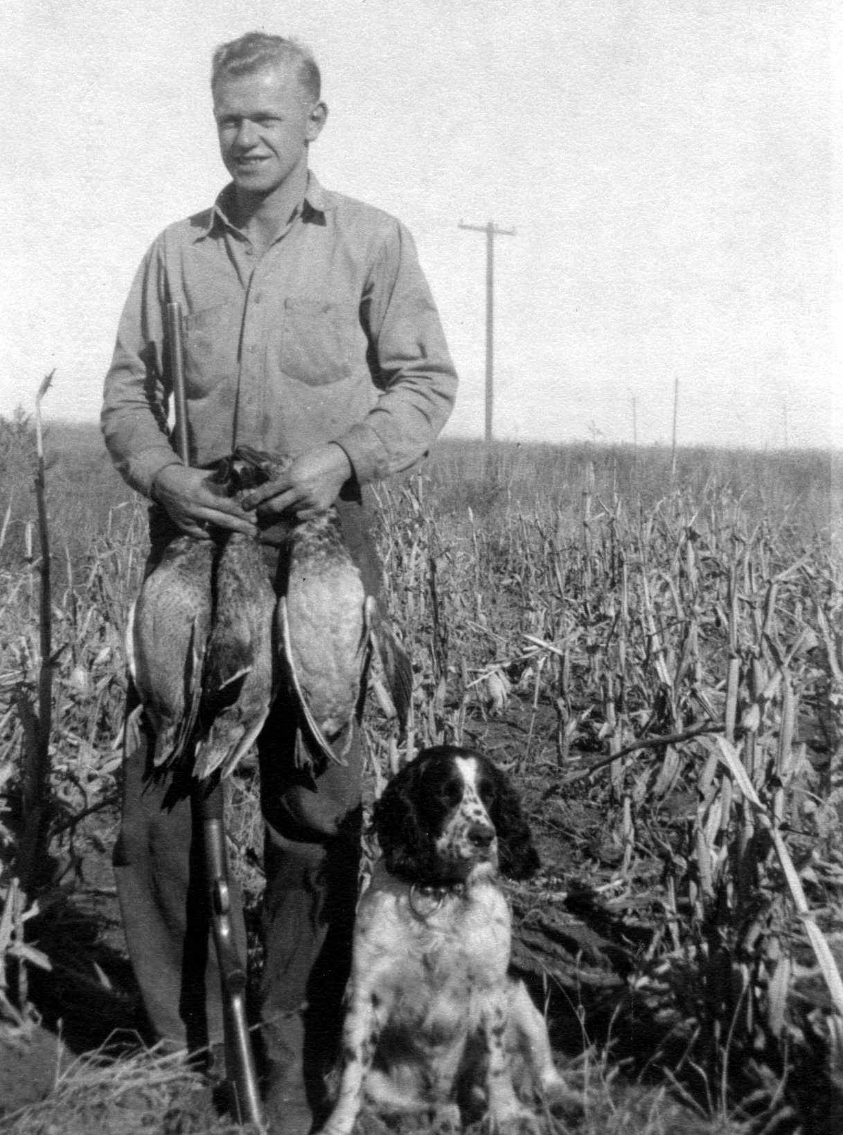
Donald, 1940s
I used to trap between Zap and Beulah on the Charlie Gentz farm. It was located just west of what is now the runway for the Beulah Airport. Charlie and Elmer worked at the Strip Mine. Their shift was from 6 am to 6 pm. They would pick me up at my house and I would check my traps with a flashlight that night. Then we had to get up at about 4:30 am and eat breakfast. They would drop me off at our house about 5:30 in the morning.

There was a hole along the Spring Creek. Charlie said someone told him it was an old trappers cave that had caved in. In the wintertime, steam would come out, indicating it went back quite a ways. This was my favorite place to trap. One year I caught 13 skunks there. One night I was walking on the ice, checking other traps, and something snarled at me in the dark. My flashlight revealed it was a mink. I looked closer and saw a trap on its foot. There was a piece of binder twine tied to the trap. The mink had eaten off part of the string and was escaping from wherever the set was. Secured, I dispatched the mink and took it home. Charlie told me perhaps it belonged to Tom Boland as he was seen in that area. They told me to keep the mink and not tell anyone the particulars.

It took me quite a few years to learn how to catch mink. I did catch a few. Then as I got older, I would boil my traps in lye water to get the oil and scent off. Then I would boil them in walnut shells to darken them and the final step was to immerse them in hot water with bee’s wax on top. The wax would coat them well so the trigger would not freeze. For a snow set, I would use an unscented Kleenex to cover the trap and lightly cover it with snow. Then I learned how to use bait. They would not come in for dead bait; they would go around it. My best set was a five-inch sucker minnow hooked in the mouth with a snelled hook. I would attach the other end to a big nail and insert it in fairly fast-moving water about four inches deep. I would then get a couple clean clamshells and lay them white side up directly below the minnow. The next step was to use a little mink scent on a stick about three feet above the set. I would put at least two traps there, one above and one below. Several times, I found mink in my traps but before they got caught, they bit the minnow.

The most I ever got was $40 for one mink. I remember, gas was selling for about 20 cents a gallon at this time. The most mink I ever caught in one year was about 30. When Marsha and Beth were small, I had about 15 all stretched and we attached them to a string and took movie pictures of them. Later we found we had no film in the camera. When I was about in the 8th grade Robert, Junior Beck and I were down to the Spring Creek hunting. It was early spring and the creek was overflowing its bank. We saw a mink on the opposite bank. I shot it with my .22 and it crawled onto an ice chunk before it died. Robert and Junior volunteered to walk up to the Zap Railroad Bridge and come back down the other side and get the mink. It was a total distance of about four miles one-way. I stayed and watched my mink. At times, the current would try and sweep the ice junk out. I would fire into the ice and knock it back. It was getting to the point where it was difficult to keep it there. Finally, they arrived and plucked it from the water. It was not in season. I skinned it, stretched it, and fleshed it good. I put it under my mattress with mothballs and kept it until fall. I think I got $18 for it. From the time I was a freshman in high school I bought all of my clothes and furnished my spending money with trapping money and wages from farm work, mine work, etc.
My father raised silver foxes. We had seven or eight pens, which were enclosed by a larger fence that we called the guard fence. We used to raise chickens and pigs in the guard fence. Sometimes we would find a chicken with no head. They did not dare to stick their heads into the fox area. The smaller fences had all-wire bottoms so the fox could not dig out. The fences were about seven feet tall and had a two-foot piece on top that was slanted inward so the fox could not crawl over the top.
I recall of two foxes escaping by tearing a hole in the fencing. One was loose for a couple days. Our neighbor girl was playing in a road ditch by herself; Florence Beck was her name. She fell asleep in the ditch. When she opened her eyes, she was severely frightened, the fox was up very close, smelling her face. When we found about where the fox was, a bunch of kids and some men went looking for it. We found it and we all chased it. Good thing there were a lot of us. It ran down to the large slack pile by the tipple. It ran around and around until it was played out and we dropped it into a gunnysack and took it home. I do not recall if we ever caught the other one.
The fox pelts brought about $75 each when Dad started. As time progressed, the Purina Fox Chow got more expensive and the price of foxes went down. We used to have a professional skinner come in to skin and stretch the pelts. Prices went down and I grew up. When I was a sophomore in high school, dad had me do this work. We had a three-foot metal tong whereby we could grab the fox by the neck. Then I would kneel on its heart area until it died. This way the pelt was damaged. Constriction of the heart took about two minutes. Later in life, I dispatched a lot of mink in this manner. After I was married, I continued to trap. Often times I took half of my vacation time to trap. We used all of the money to buy Christmas presents and we had some real big piles of presents under the tree. I would usually get between 20 and 30 raccoons.
I also recall one time I had a big horned owl in my trap. It was very cold and it was all wet. His foot was not damaged too much. I put it in a gunnysack, took it home, and kept it in the basement all night so it could dry off. Next day I took it outside and set it in a tree and it stayed right there. I walked back to it and petted it. Lenore then got the movie camera and took pictures of me petting it. It was still there in the evening. I had skinned a mink and I took the carcass out to feed it to the owl. As soon as it smelled the mink, off it flew.
It was about this time that Fred Flemmer, the local Banker, wanted some beaver pelts to have some beaver skin coats made for his granddaughters. We had to contact the game warden and he would go to the landowner property and inspect the area to see how much beaver could be taken from that area. We would then get metal tags to attach to the pelts after they were skinned. We were trapping in the wintertime. We would find where they would crawl up under the bank in a hole to eat their twigs. You could always see a bunch of shiny twigs with the bark chewed off, so we knew where the holes were. We would tie a heavy weight to a wire and poke it out in the deep water. We then attached a wire clip that would slide down the wire but not up. To this we attached the trap. Bud could not take the cold on his hands and arms (or else he was a lot smarter than I was). I would take off my jacket and sometimes my shirt and lie on the ice and reach in the water as far as I could and place the trap way up in the hole. One day it was 20 below zero when I was doing this, my arm was beet red. Years later I had bursitis in this arm, and I think that the cold did it.
Another way we would catch beavers was by cutting a hole in the ice. We would then get a four-inch tree and nail a small platform on it big enough for a trap. Above the platform, we would nail some green tree branches. The beavers would drop down to get at the branches and step on the trap. They drowned quite rapidly. After a few years, beavers became so plentiful we no longer needed tags. They opened the season for everyone and allowed us to shoot them.
When they dammed up the Missouri River, they encouraged people to hunt because the rising water would drown the beavers out in the wintertime. Over the years, we must have taken over 400 beavers from around here. One day I told Kim, I am going to go shoot a beaver and have a hat made from that. I drove down to the river, looked over the bank. There was one sitting. I shot it and was back home 20 minutes later. I did have a hat made from that.
Now back to the earlier days, we had neighbors, Jake Beyle and his wife Florence, and their two daughters, Bernice and Violet, and one son. Bernice was Roberts’s age. When Robert was still small and nursing, Mrs. Beyle gave birth to Bernice. She was also nursing her daughter and had more milk than she needed. My mom did not have enough. Mrs. Beyle would often bring some over for Robert or she would take Robert home and nurse him.
About this time I started to work wherever I could get a job. I did shocking grain for 30 cents an acre. In those days, there were no combines and the farmers had binders, mostly pulled by four horses. A little later they did have tractors. The binders would cut the grain and tie bundles of it up with binder twine, much like the hay twine of today. We would have to pick up the bundles and stack them in about 12 to a stack with the heads of the grain in an upright position. This was to make it dry out. After about two to three weeks, it was time to thresh the grain in a threshing machine.
We had teams of horses pulling a hayrack and we filled the rack with grain bundles. Then we would pull up along side of the threshing machine and throw the bundles unto a moving hopper. From thence, they would enter into the machine where arms threshed them and knocked the grain loose from the plants. The grain came out of one hopper and the straw came out of another and blew it into a pile that of course was called the straw pile. Before my time, my grandfather Wetzel had the first threshing machine in this part of the country. It was powered by a steam engine and they would burn the straw to fuel the steam engine. My father and uncles were part of the labor force. They used to go as far west as Halliday, about 40 miles away.
Anyhow, I was telling my neighbor, Dave Johnson, about the steam engine. He told me that his grandfather back in Minnesota had the first one in that area. He was driving his engine over a bridge that spanned a river and the bridge collapsed and his grandfather was killed.
Teen Years
About 1939 or 1940, war clouds were looming over Europe. The United States started to prepare for war. Men were drafted into the army. Defense plants started to manufacture war goods. Car factories were making jeeps, tanks, guns and war goods. You could no longer buy a new car. Sugar, catsup, shoes, meat, gas, tires, toothpaste and many other items were rationed. Everyone had a ration book with stamps in. I think you were allowed two pair of shoes. We were allowed three gallons of gas a week. Before rationing started, some people were buying sugar and canning it. I do not know how this turned out. Most people did not have enough money to buy things ahead. I do not know how much meat we were allowed. We only purchased meat twice a month, on payday. Usually it was round steak. I do not remember ever eating T-bone steak until after I was married. When you purchased toothpaste, you had to turn in the old toothpaste container. I believe it was made of lead and recycled.
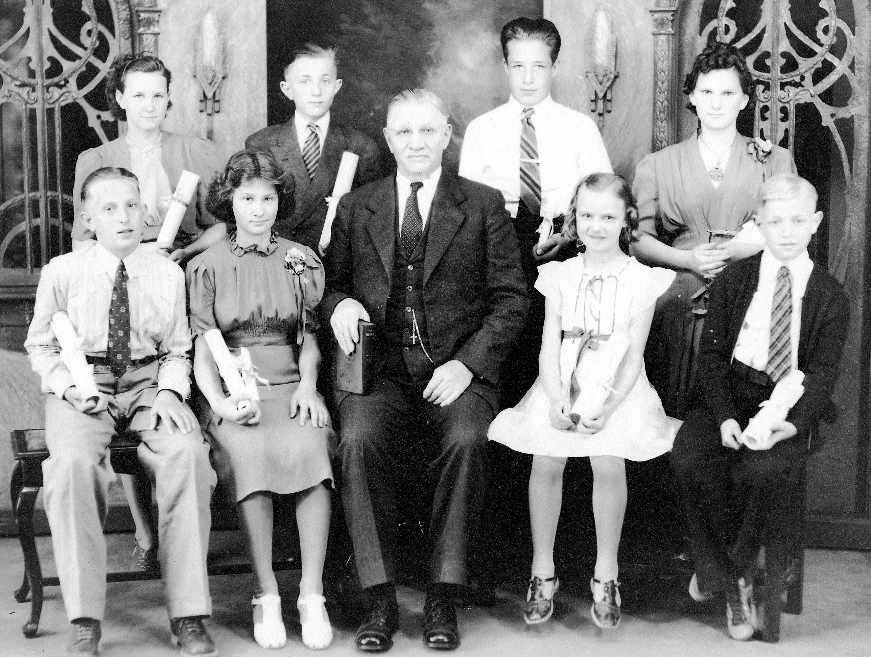
8th Grade Graduation, 1941
On December 7, 1941, the Japs attacked Pearl Harbor. It was a Sunday. Robert, Lloyd Hilz and I went jack rabbit hunting. We walked about five miles over to the Keogh ranch. I shot five rabbits by time we got that far. Lloyd had none. We started home and Lloyd would not help us carry the rabbits. The rabbits would bring about 25 cents each. Candy bars sold for five cents each, if you could get them. Ice cream was five or ten cents a cone and that, we could get. Gas was 20 cents a gallon.
When I was in high school, we did not have basketballs to play with at home. I used to go to the home games in Zap and I would keep score. This was when I was in the 8th grade. There was a small blackboard hanging on the wall, across from where the spectators sat. I had a piece of chalk and would scribe down the scores. When a basket was made, I would erase the old score and scribe in the new score. Scoring was not high in those days.

When I was a freshman, the coach asked my father to drive part of the team to Stanton. We never did go in buses, always in private cars. I was on the Cub team and without a doubt one of the worst players. We only took six players for the cubs that night because of the shortage of cars. This was in 1941 and gas was rationed by then. Because my father drove, the coach permitted me to go along, and that was the only reason I got to go. Anyhow, as I recall the score was tied 13 to 13, with about 30 seconds left. I know the coach felt guilty, as I was not put into the game. He put me in, and I don’t think anyone was worried about me. Someone threw me the ball and I shot and made it. I was fouled and got one free throw. I made that also. We won by 3 points. I still have that clipping in an old scrapbook. The next year I was playing for the big team. I was just a sub until my junior year. In my senior year, I was chosen as one of the all-tournament team at the district class B tournament in New Salem. In those days the coach could not talk to you during time outs or between quarters, it was a technical foul. Anyhow, we played Elbowoods. They were much better than us but we outsmarted them. Four of us would all pull over to one side and another man would break away and be open under the basket. We beat them. However, all we were was consolation champions as I recall. That was quite a feat for us as we were one of the smallest teams. I think we only had seven players.

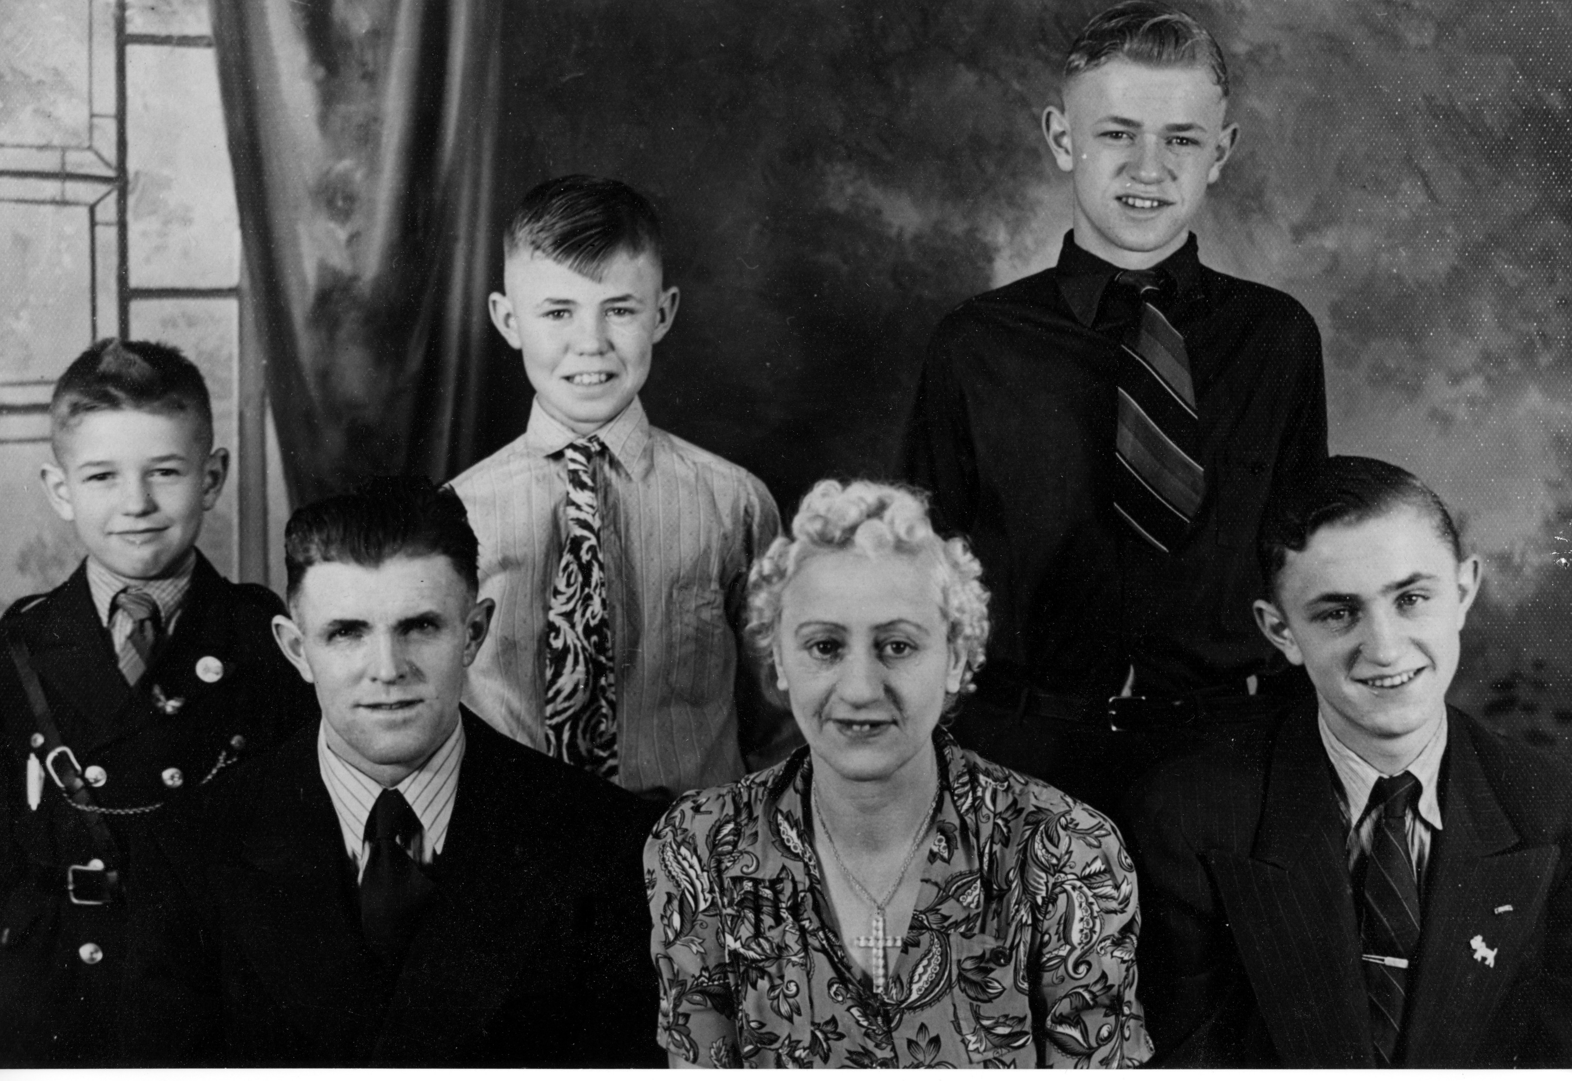
Harry Wetzel Family, about 1942
When I was a junior in high school, I got a job working for the Northern Pacific Railroad, during the summer months, at Dawson North Dakota. I got my social security card then and it came out of St. Paul, Minnesota. It had a different starting number than North Dakota's numbers. I was asked many times, where I got my number. Junior Beck accompanied me. Our job was to take a pick, and scratch away the gravel on both sides of the ties. Then a crew would raise the rail slightly and another crew would jackhammer the gravel under the ties. Junior and I were the only ones scratching the gravel, perhaps because we were the youngest. In two days, we were about ½ mile ahead of the crew. The foreman told us to slow down and take it easy.
The food was not too bad, but breakfast was terrible. It was usually pancakes and eggs. There was no syrup for the pancakes as it all went for the war effort. Instead, we had molasses. It was years before I could stand the smell of molasses. I think the pay was about 50 cents an hour, but we had to pay for our board and room. Our room was a railroad car with four bunks at each end and those big sliding doors you still see on railroad cars today. They did not heat up too badly. There were no windows, but we did close the sliding doors every night. When we were through there and after I got home, Frank Pulver came and got me to help with his harvesting.
Frank had a threshing machine and did threshing for some of his neighbors. He had Dale and Bud Pulver help, both much older than me. After he was through at his place, he let Dale and Bud go because I was a better worker than they. I always helped Frank unload the wheat and milk the cows after I had taken care of my team of horses. The other men would wash up and set in the house and talk. After my junior year in high school, Junior and I applied for jobs as firefighters in the Coeur d’Alene, Idaho area, working for the United States Forest Service.
We got train tickets to get there. My mother packed us a lunch of chicken sandwiches. This was in the middle of World War Two. As a result, all war trains and troop trains had first priority. It took us three days and two nights to get out to Spokane, Washington. From there, we had to catch a bus back to Coeur d’Alene. Our train would pull into a siding whenever a war train was near. Sometimes we would wait for several hours. It was interesting to see those trains going by with tanks, jeeps, big guns etc. When the troop trains came by, people would line the tracks and hand out cookies and food to the GIs. They would be at the windows waving to the people.
We did not touch our lunch until the second day. We were used to not eating very much. There was a water cooler on the train for drinking. We checked into the Forest Service Office in the afternoon. They loaded us on a bus and took us about 34 miles out of Coeur d’Alene. We arrived at Camp Hudlow, an old CCC Camp at about 6:00 pm. Supper had already been served. They asked if we wanted to eat. We said we would be okay until breakfast.
Our job was blister rust control. One man would go up the mountain and throw balls of string down; this would mark out lanes. Each man had a lane and would work up the mountain removing gooseberry plants. (the plant that spread the blister rust).
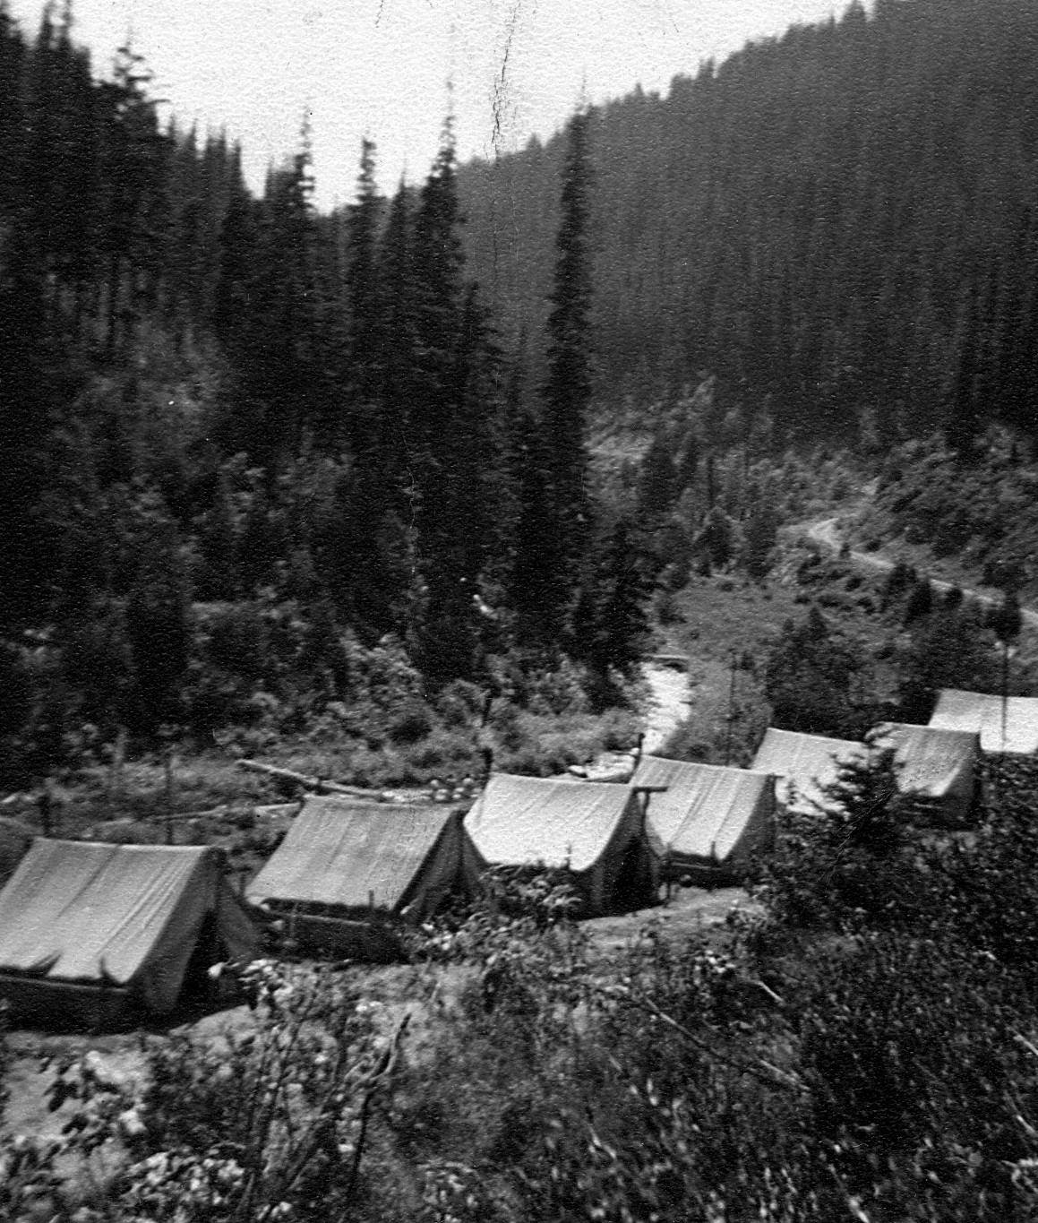
Burnt Creek Camp, Idaho, 1943
After the first week, an active fire fighting crew was formed. We still did blister rust work in off -time. I was one of the ones chosen. Our crew consisted of 21 men. We were then moved to a tent camp where a small stream joined Burnt Creek. They called the camp Burnt Creek Camp. Our camp was located near the junction. The stream was about 15 feet from our tents. We slept four to a tent on army cots with sleeping bags. Of course, there was no electricity there. We had little stoves in each tent. I was with Suggs from Arkansas, Don Johnson from Minneapolis and Billings (his nickname) from Billings Montana. I have forgotten his real name. After he went home from there, he was delivering newspapers before school on his bike and he was killed. His father was a banker.
We went to a fire at Missoula, Montana. We had seats bolted down in the back of an open truck for our travels. It was a big fire. I do not recall how long it took us to get there. As soon as we got there, we were sent up to the fire line. By the time we were able to get down for a rest, 40 hours had elapsed since the time we had left our camp. We were bone tired. However, they did not get any food up there. We had oatmeal for supper with Carnation milk. We had the same thing the next morning for breakfast. It was years before I could stand the taste of Carnation milk. Anyhow, after 40 hours of no sleep, we got in line where we were issued sleeping bags. I was so very tired. I lay down on the rocky hillside and no matter how I tried, I could not find a smooth spot. It seemed like there was always a little rock in my back. Maybe that is why they call them the Rocky Mountains. I got back in line, got another sleeping bag, and used that for a mattress. Slept like a log. After that, I always went back and got two sleeping bags. They also brought in some GIs who had just come back from fighting in Europe. I think to them it was not too hard of a job. We were there about four days before we were allowed to go back to Idaho.
A different time we went 40 hours without sleep. There were a lot of small fires and 14 of us were sent into a small blaze. We finally got it under control. There was no food, but someone had some army rations enough for three meals for one man. We decided we would draw straws for the food. I got a small can of bread - not very tasty. We were told we could lie down and get some sleep. We had walked up there so we did not have any sleeping bags or anything. I had read how you could make a bed from pine boughs. I tried that. I must have made them too big though, because they stuck me. The crew leader asked for volunteers to go back to the ranger station to report in. I and another boy volunteered. He said he knew the way. It was dark but the moon was out. He led the way. The hat he wore was felt and he had soaked it in water and stretched it out over a stick. It was pointed like a Gremlin’s hat. When his image was silhouetted against the full moon, I thought for certain I was following a gremlin.
We arrived at the lookout tower and the man said. I have been up as long as you fellows. I am not going to get up. Make your call to headquarters and then you can start a fire and make yourself a pot of coffee. There was no electricity or gas in those days. We started a wood fire in his little stove, put the coffee pot on and thought we would lay down on the cots while the coffee brewed. The next thing we knew, the sun was shining in our eyes. The coffee had brewed. The fire was out. The coffee was very cold. We did not drink any. We were worried because we did not return right away, so we left our post in haste. When we got down to the fire, the rest were still sleeping, and the fire had not flared up. We mopped up the fire and two men were left to watch it. Six hours later, we were on our way down the mountain.
I usually did not get to start school on time; I was usually about two weeks late. However, this particular year, Otto Sasse from north of Zap, asked me if I would please help him for a few days. My third day there I got up really feeling ill. I ate breakfast and went into the barn to harness my horses. I felt so badly I laid down in the hay manger. When the rest came out, they felt my forehead and knew I was ill. They took me home. I had phenomena. My mother rubbed my chest with goose grease, skunk oil and put on hot mustard packs. I recovered. No one went to the doctors in those days unless it was really serious. There was not such a thing as health insurance.
While I was in high school, oftentimes men would not show up for work because of the war. Employers would call me out at about 5:30 a.m. to fill in. Usually I would be a firefighter on one of the little steam engines. At that time, five steam engines hauled the coal from the pit to the tipple. The last mile was pretty much downhill.
Once I was a firefighter for Matt Bushbacker. As we were going down the long hill, he tried to slow the train. The tracks were snowy, and the sanders were frozen up. The sanders laid a layer of sand on the tracks for stopping and starting. There was a prearranged signal for the tipple. They had ties and other timbers to put on the tracks to stop the train. Years before, a train had gone into the tipple where we dumped the coal. It had done a lot of damage, so they devised a signal. The signal to alert the tipple personnel was to hold the whistle down. Matt told me to hold the whistle down. He told me to jump if we did not get stopped in time. He crawled out the window with a hammer and pounded on the sander pipes. Soon he got one side working. He crawled over the top of the engine and started to pound on that side. Soon that was cleared, and the brakes started to hold. We came close to the pile of timbers but got stopped before we hit them. I saw Matt 50 years later and asked him if he still remembered that. He did.
Before we got into the war, we were building up our troops and war supplies. Rationing went into effect. We were allowed 3 gallons of gas per week. Tires were rationed but almost impossible to get. The speed limit was put at 35 miles per hour to conserve gas and everyone followed the rules. We had ration stamps for sugar, syrup, catsup, meat, and shoes. I am not certain, but I think we had rations for coffee too. The stores did not carry chickens in those days because farmers and a lot of the townspeople had their own. We raised our own.

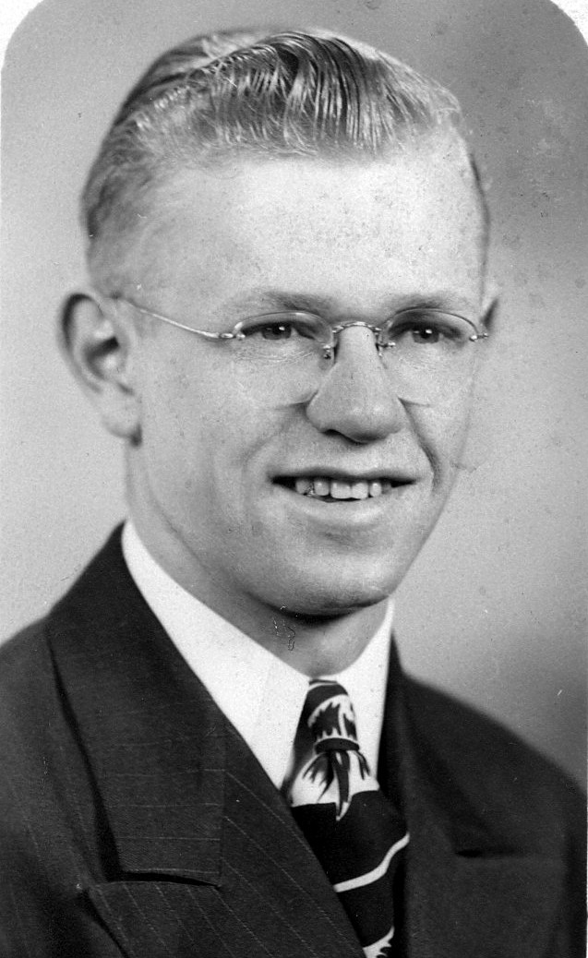
High School Graduation, 1945
World War II
I tried to enlist in the Navy in February when the recruiter came around. They sent us to Fort Snelling in Minneapolis for our physical. I had purchased some candy in Bismarck and ate it on the train. When we took our physicals, Junior Beck could not fill his urine sample. I filled mine then I filled his. I failed the test. My sugar content was too high. He passed his with my second sample; not fair. Anyway, I told him I was going to walk across the street and join the Merchant Marines. Alvin Klause went with us. He failed his physical there, but he had passed for the Navy. The testing was not very uniform. We were sworn in and told to go home to await our call. We went home and I did graduate with my class. My grades were good enough; I would have graduated even if I had left in February.
After high school, while waiting to get a call from the Merchant Marines, I worked again as firefighter. Lester Bauer, a friend, was also a firefighter. When we were through at the tipple we would pull in at the top of the hill, about 1/4 mile from the tipple. There was a
water tower there and we would fill our engines with water every trip. In addition, that is where they kept the sand for the sanders. The water tower was on a spur. We would get out, run ahead, and throw the switch so the train would go into this spur. The switch had a heavy weight with a grove in it that we would catch with our fingers and throw open. Lester Bauer filled that opening with grease when he knew I would be the next one to throw it open. Of course, I ran up to the switch and as I tried to open it, my hand slipped, and our train went by the spur. We backed up then and then got up to the water tower.
I waited for my turn to turn the tables on Lester. Finally, he was behind me. I greased up the switch just as he had done. Then I took the oilcan and oiled the tracks for a short distance. As they went by the spur as we had
done, they applied the brakes. Of course, they just slid along. Then they had to use their sanders. As I think back, this could have been dangerous if another train were coming from the other direction.
I do not recall the exact date we got our call to report to Minneapolis to go to the Merchant Marines. It was a long train ride, but we did have sleepers. We arrived at Grand Central Station in New York City. That is quite a place. It seemed like we were on the outskirts of New York City for about 50 miles. There must have been about 30 of us from the Midwest. Someone met us at the station. I forget how that came about. We would never have found our way to boot camp without help. It was on the very tip of Brooklyn. Sheepshead Bay was the name. We were not there very long before the war ended. There were a lot of street parties. Brooklyn was a very friendly area. We did not get liberty until 4 or 6 weeks. Then we really explored the big city: Central Park, museums, Zoos, The Museum of Natural History. There was a canteen on the apex of Times Square. It was right across from Madison Square Garden. Pepsi Cola sponsored it. You could have all the free Pepsi you wanted. They also served hotdogs for a very small amount of money, ten cents I believe.
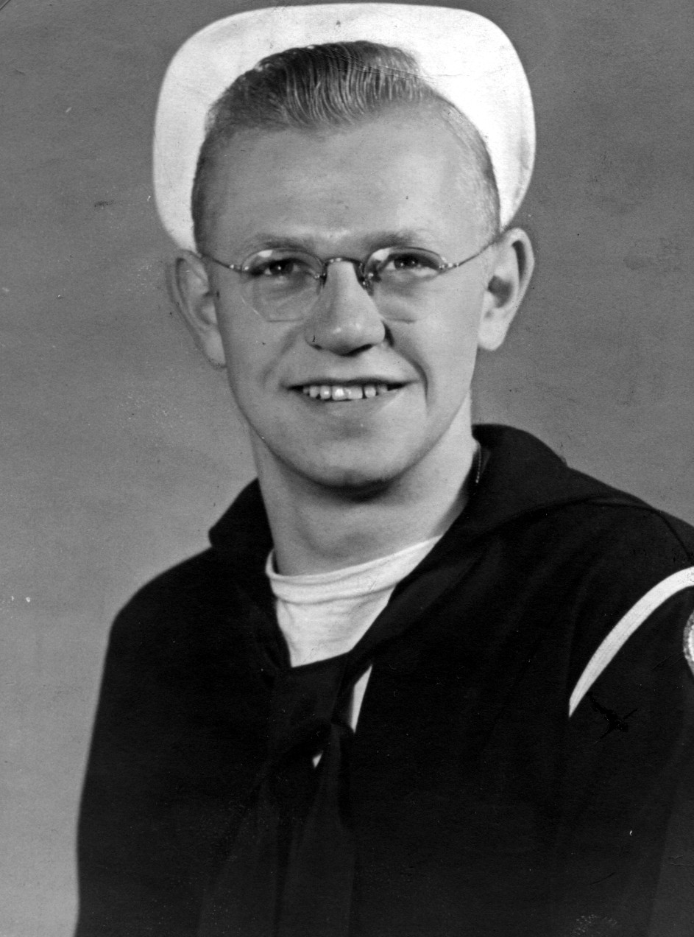
Merchant Marines, 1945
On my 18th birthday, I took about four of my buddies and we went into Jack Dempsey’s Bar. I bought them each a glass of beer for 49 cents a glass. This was a special price for servicemen only. I think it would have been close to $2 a glass for everyone else.
I belonged to a racing crew. It was called lug racing. We would sail out to a spot about ½ mile out into the ocean. Then we would row back. I think there were 13 on the crew. We held the station record. We always won. As a result, we got mid-week liberty on Wednesday. The boat was quite large, like a lifeboat. We used to stop off in a small bar and have a beer before we returned to camp after liberty. The bar had a piano on a high stage and sometimes someone would get up there and sing, just like you see in the old movies. We would only drink one or two glasses of beer. We did not have much money. Beer was only ten cents a glass for us.
Finally, boot camp was over. I was assigned to a troop transport, the USS Joseph Hewes. We were to go to England and pick up troops returning home from the war. It was the storm season in the north Atlantic. This was a Liberty ship and did not travel too fast. After we were out for about five days, one of the
hands came down with appendicitis. We had no surgeon on board. We made radio contact with a ship returning to New York Harbor. We stood off about 1/4 mile. The ocean was very rough, with waves that were perhaps 20 feet. At first, they were going to try and move him over on a breeches buoy. That is where you shoot a line over to the other ship and then pull up a bigger line. There was something like a basket to pull the man over. Due to the rough water, we could not do that. They lowered a lifeboat and transported him over. Half of the time, you could not see the lifeboat because of the high waves. We did not know it then, but we were in for much worse in a short time. Everything went off well and soon we were on our way. About that time the Queen Mary, passed us, returning with a load of soldiers. That was a large ship. It too was perhaps ½ mile or better away.
All of the garbage was thrown overboard. There were three dolphins that followed us all of the way. They would feast on the garbage. Later on, we would see a very large school of dolphins pass us. It must have been ½ mile across. They swam like you see on TV, always coming out of the water.
A day or two later a storm struck. The waves were over 60 feet high. All our ship could do was slow down. When we crested a large wave, our fantail would come out of the water and the ships propeller would come out of the water. It would speed up and as it fell back into the water the whole ship would shutter and shake. Some of our deck plates heaved. We were not moving ahead, just holding into the wind. After two or three days, the wind went down. The next morning there was a white artic owl perched in our rigging. The storm must have blown it out to sea. It was there about a day and then was gone.
Years later, Father Roth, our local priest and my hunting and fishing buddy, had a visit from his long-time friend, Father Wilson. Father Wilson was in the Bataan Death March and he told us of some of the atrocities of the Japanese soldiers on this march. Later on, they moved them to Japan. While getting off the ship, the Japs would push the American soldiers into the water where the ship was bumping into the dock and crushing them. Father Wilson weighed 98 pounds when he was freed. He told us when the war ended there were two really mean guards. They left post haste. Some of the Americans were going to get them. Father Wilson tried to talk them out of it, but to no avail. They came back later with their two heads in a sack.
My cousin, Doris Hague’s husband, was in the Philippines. General MacArthur told their commander not to shell Manila because MacArthur’s wife owned a hotel there. He told him, if you do, you will be in every major battle from now on. They did shell Manila. This group was scheduled to go on a 6-week rest and recuperation leave. They did not get to go. MacArthur kept his promise. What a small man to be a General. He should not get any respect in the war chronicles.
When the war came, my mother’s brother, Charlie was either drafted or he enlisted in the Army. After some time, he was sent overseas. In late 1943 or 1944, my grandfather got a telegram from the war department telling him that Charlie was missing in action. We did not hear a thing for about six months. Then we got a letter from Charlie. About two years later, after the war, Charlie came home for a visit and told us this story. A German soldier carrying a white flag approached Charlie’s company commander. He informed them that they wanted to surrender. Charlie told me they followed this soldier down a valley, between two hills. (Many years later my brother Jim was in the Navy and near that spot. He went and viewed the area in which this happened.) The Germans were up on top and started shooting them. Charlie was hit several times, but he said he ran and ran. Finally, he could run no longer and fell. The Germans came and kicked the two men next to him and they flinched. They were shot in the head. When they kicked Charlie, he played dead. The Germans then tore the dog tags from their necks. That was the reason they did not know who he was. I suspect they took his billfold if he had one. Charlie did not even remember his name until six months later. He spent about
two years in the hospital in the states. My friend, Chip Unruh, was stationed at the Jacksonville Air Force Base. I gave him Charlie’s address and he went up to see him.

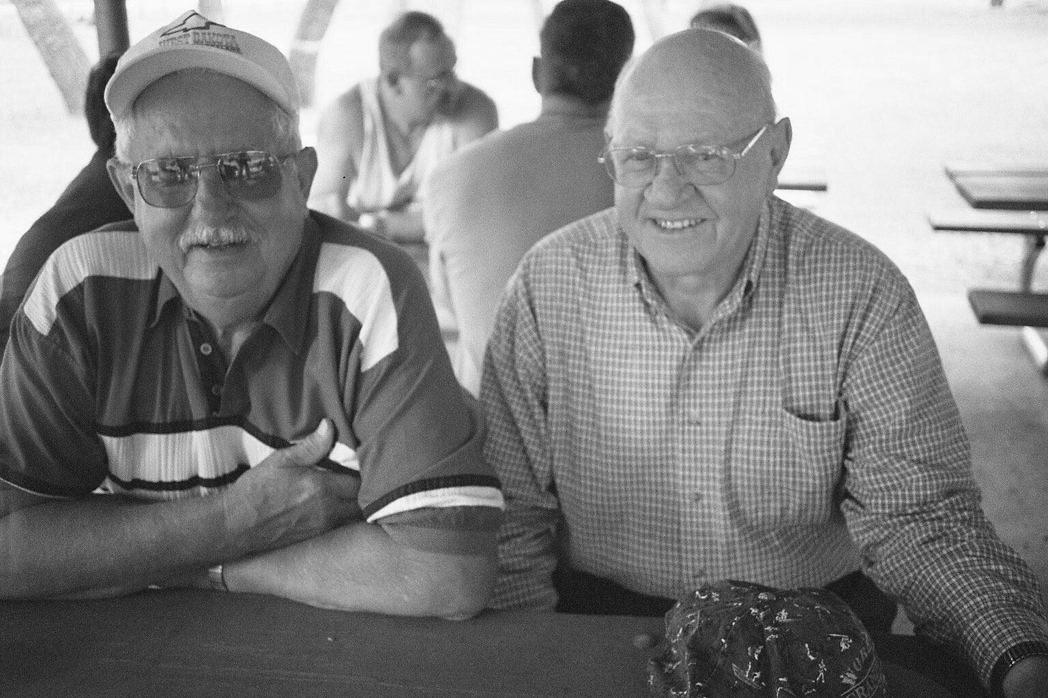
Chip Unruh and Donald, 2002
Today I went over to the Civic Center for a free meal put on by industry. My friend, Chip picked us up a lot of free pens etc. at the various booths. We stopped at the Coteau Mining booth and visited. I told them I worked at the Strip Mine for cents an hour and got paid out of the cash box because I was too young. We told them about the shovels and draglines and little dinkies that hauled the coal to the tipple. All of these were steam operated. After I got home, it dawned on me that perhaps we were the only ones left alive that worked at the pit during this time. The Pulvers at Zap worked at the tipple and they are still around too.
The worst working conditions I ever had to work in were in January. It was 42 degrees below zero. Our high-power lines between Beulah and Hazen kicked out. I had a terrible headache and a cold; every time I coughed, I thought my head was going to split. As I left the house, I grabbed Kay’s scarf. We started patrolling the line. Our man at Hazen had a snowmobile. We got to some very rough terrain and he was going to check things out with his snowmobile. We got the snowmobile running, but it was too cold. It was so stiff the transmission would not turn the belt. So, we walked it.
After a very short walk, we found a downed power line. It was about a 50-foot pole. We put on our Coffing hoists to pull the line together. We could not splice it on the ground. Bud Pulver and I went up the pole. They pulled up everything and we proceeded to jack the two ends of the wire so we could put on a splicing sleeve- a copper piece with holes in each end. We had a compression tool to compress the sleeve around the wire. Then I noticed Bud’s face had a white spot on, it was starting to freeze. There was just a faint breeze and he was facing it. I pulled up my scarf and traded places with him. He put his hands over his face and soon the white spot disappeared. Several times, he noticed white spots on my face that was uncovered, and we would stop work and hold our hands over our faces to thaw out.
We compressed the sleeves and released our hoist. The wire snapped again. We went through the process again, and again the wire snapped. We then spliced in a six-inch section. It was so cold the wire had contracted too much. That is why it broke. This time the splice held. We had put our grounding chains on several miles away, near the road. They were made from the insulated wires that welders used. When we took them down, they were frozen. We could not coil them up. The insulation broke so we just threw them in the back of the truck. They were ruined.

